Week4 assignment

Chinwendu Imegwu

1. Create Multiple User Accounts

- Create five new user accounts: `student1`, `student2`, `student3`, `student4`, and `student5`, each with a home directory and default shell.

```bash

sudo useradd -m -s /bin/bash student1

sudo useradd -m -s /bin/bash student2

sudo useradd -m -s /bin/bash student3

sudo useradd -m -s /bin/bash student4

sudo useradd -m -s /bin/bash student5

```

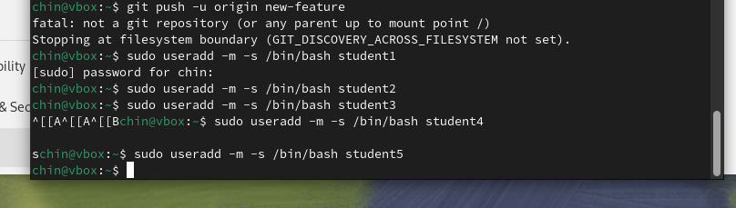

- Set a password for each account:

```bash

sudo passwd student1

sudo passwd student2

sudo passwd student3

sudo passwd student4

sudo passwd student5

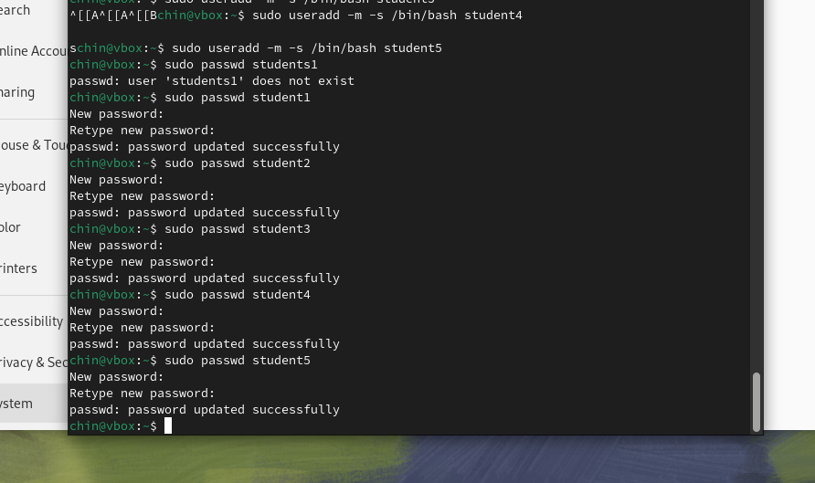

2. Modify an Existing User Account

- Change the default shell of `student1` to `/bin/zsh`.

```bash

sudo usermod -s /bin/zsh student1

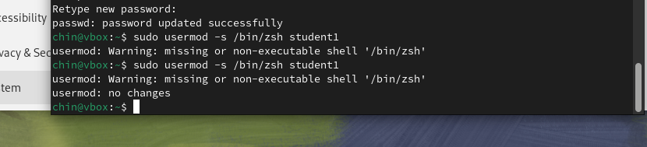

3. Delete a User Account

- Delete `student5` and remove their home directory.

```bash

sudo userdel -r student5

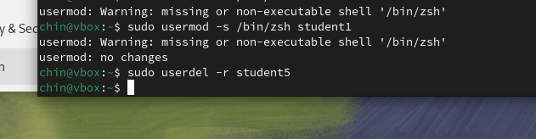

Part 2: Creating, Deleting, and Modifying Local Groups and Group Memberships

1. Create Multiple Groups

- Create three new groups called `developers`, `designers`, and `testers`.

```bash

sudo groupadd developers

sudo groupadd designers

sudo groupadd testers

```

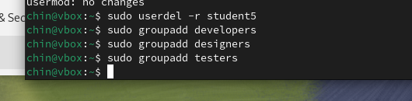

2. Add Users to Groups

- Add `student1` to `developers`, `student2` to `designers`, and `student3` to `testers`.

```bash

sudo usermod -aG developers student1

sudo usermod -aG designers student2

sudo usermod -aG testers student3

```

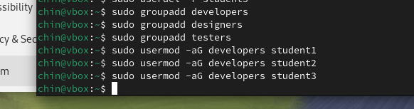

3. List a User’s Groups

- Verify the groups that `student1`, `student2`, and `student3` belong to:

```bash

groups student1

groups student2

groups student3

```

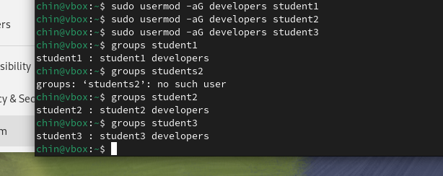

4. Delete a Group

- Remove the `testers` group.

```bash

sudo groupdel testers

```

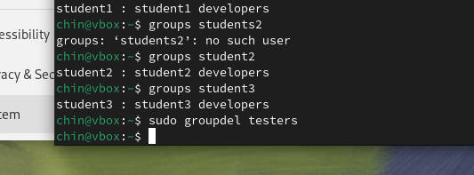

1. Edit Global Environment Variables

- Open and edit `/etc/profile` to add a new environment variable, `PROJECT_PATH`.

```bash

sudo nano /etc/profile

```

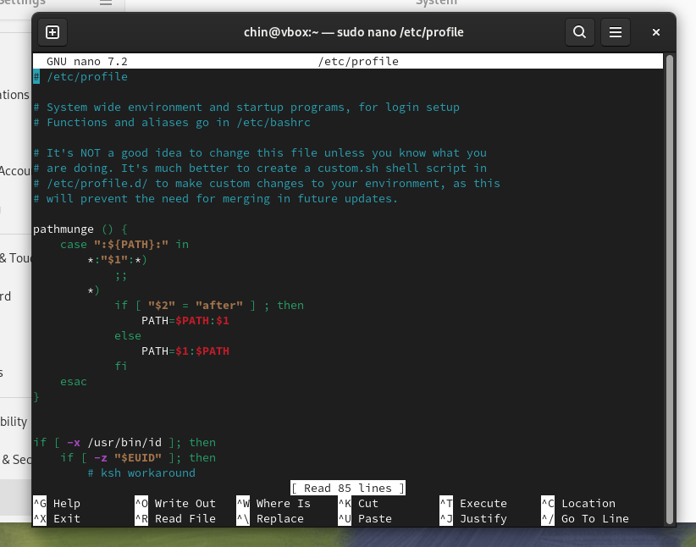

- Add the following line to set `PROJECT_PATH`:

```bash

export PROJECT_PATH="/usr/local/projects"

```

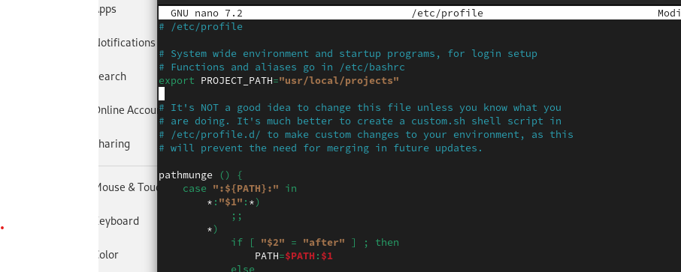

2. Verify the New Environment Variable

- Log out and log back in, then use `echo` to verify the new variable:

```bash

echo $PROJECT_PATH

```

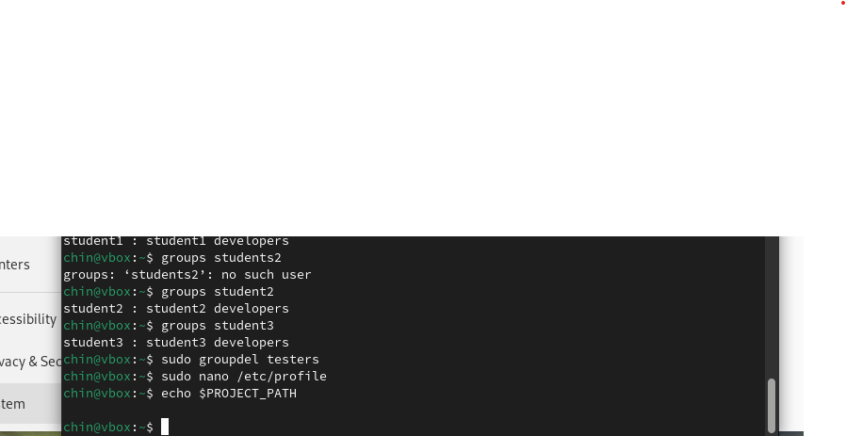

Part 4: Configuring the Template User Environment

1. Modify the Default User Files

- Edit the `/etc/skel` directory, which contains the default files for new user accounts.

- Create a welcome message in `/etc/skel/welcome.txt`:

```bash

echo "Welcome to the system!" | sudo tee /etc/skel/welcome.txt

```

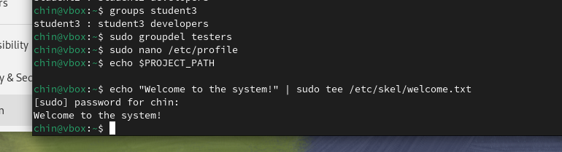

2. Verify the Template

- Create a new user, `student6`, and check that `welcome.txt` appears in their home directory:

```bash

sudo useradd -m student6

ls /home/student6

```

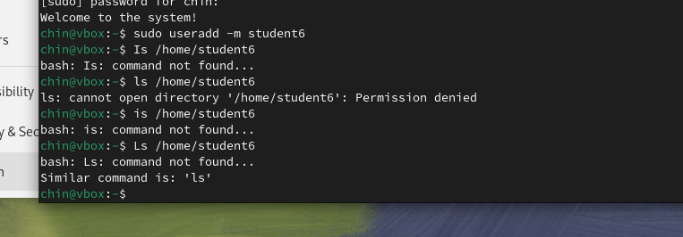

Part 5: Configuring User Resource Limits

1. Set Resource Limits for Users

- Edit `/etc/security/limits.conf` to set resource limits for `student1`.

```bash

sudo nano /etc/security/limits.conf

```

- Add the following lines to restrict `student1`’s usage:

```plaintext

student1 hard nproc 100 Max number of processes

student1 hard nofile 50 Max number of open files

```

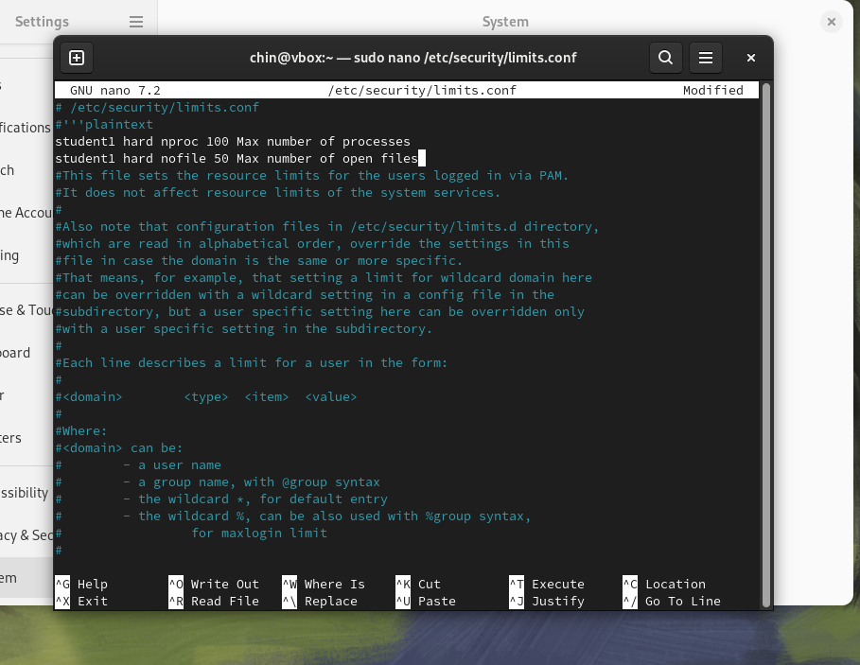

2. Verify the Resource Limits

- Use the `ulimit` command to check the limits in effect for `student1`:

```bash

su - student1

ulimit -a

```

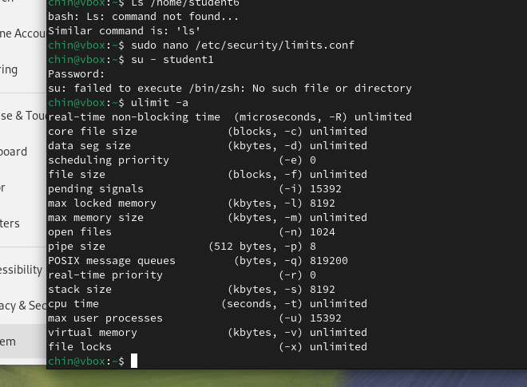

1. Configure `sudo` Access for a User

- Add `student1` to the `sudo` group:

```bash

sudo usermod -aG sudo student1

```

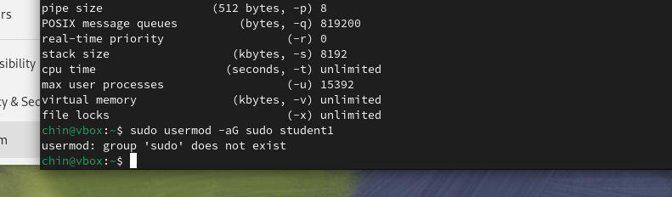

- Verify that `student1` can use `sudo` by switching to `student1` and running a command:

```bash

su - student1

sudo ls /root

```

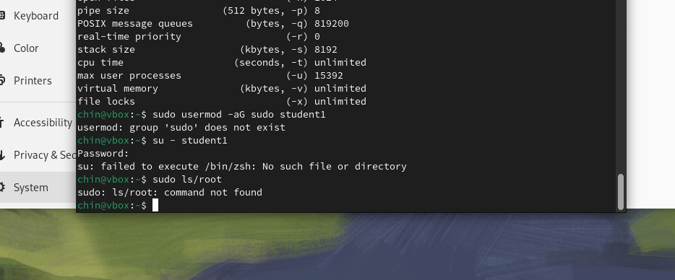

2. Configure Limited `sudo` Access Using `visudo`

- Open the `sudoers` file with `visudo`:

```bash

sudo visudo

```

- Add a line to allow `student1` to only restart the Apache service:

```plaintext

student1 ALL=(ALL) /usr/sbin/service apache2 restart

```

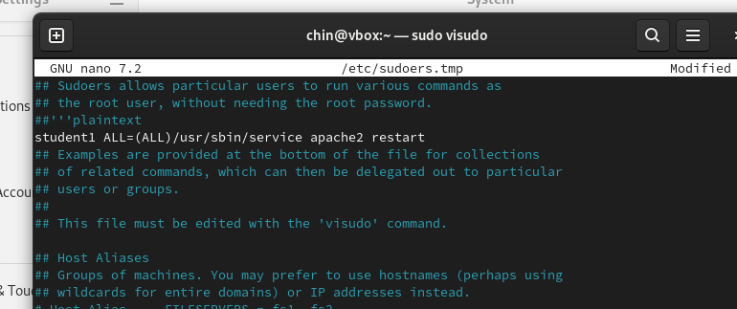

1. Disable Root Account Login via SSH

- Open the SSH configuration file:

```bash

sudo nano /etc/ssh/sshd_config

```

- Find the line `PermitRootLogin` and set it to `no`:

```plaintext

PermitRootLogin no

```

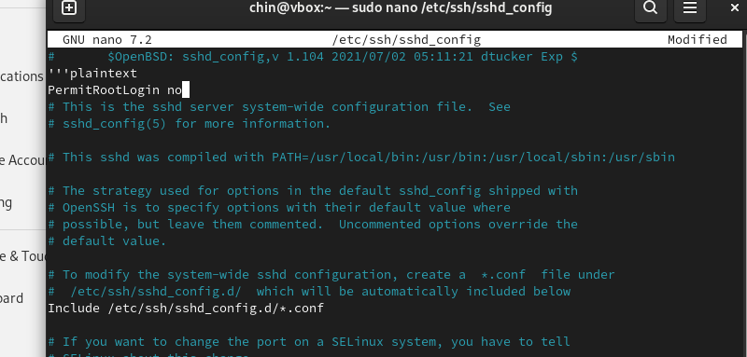

- Restart the SSH service:

```bash

sudo systemctl restart ssh

```

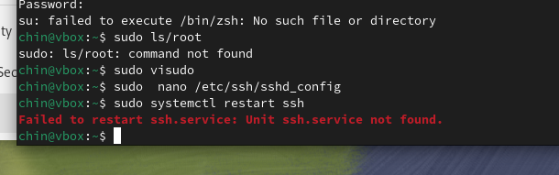

1. Install LDAP Packages

- Install the `ldap-utils` and `libnss-ldap` packages:

```bash

sudo apt install ldap-utils libnss-ldap -y For Ubuntu/Mint

sudo yum install openldap-clients nss-pam-ldapd -y For CentOS

```

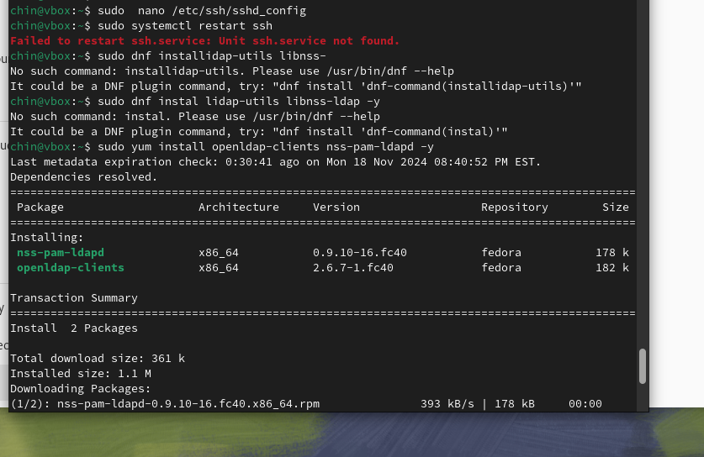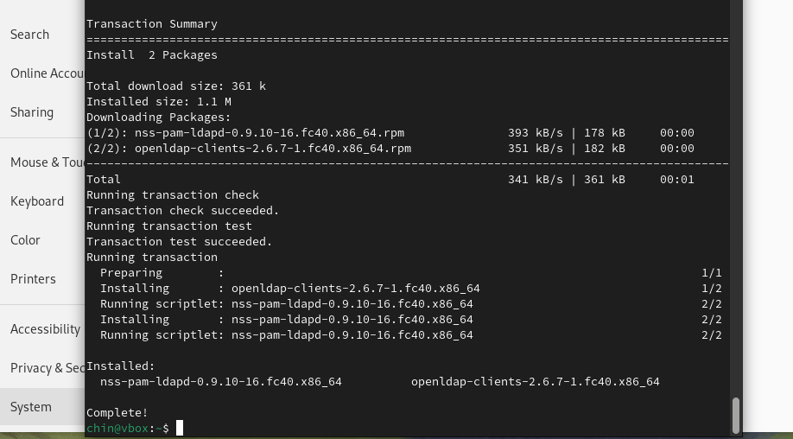

2. Configure LDAP Authentication

- Run the `authconfig` command (for CentOS) or `dpkg-reconfigure` (for Ubuntu) to connect to an LDAP server:

```bash

sudo dpkg-reconfigure ldap-auth-config Ubuntu/Mint

sudo authconfig --enableldap --enableldapauth --ldapserver=<LDAP_SERVER_IP> --ldapbasedn="dc=example,dc=com" --update CentOS

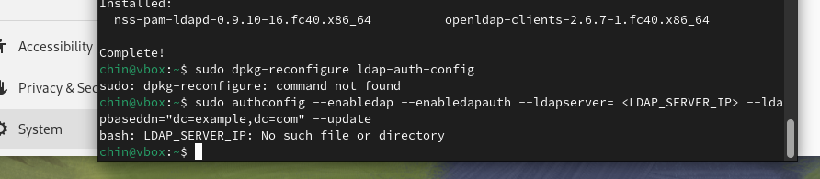

3. Verify LDAP Configuration

- Use `getent` to verify LDAP-based user and group accounts are accessible:

```bash

getent passwd

getent group

```

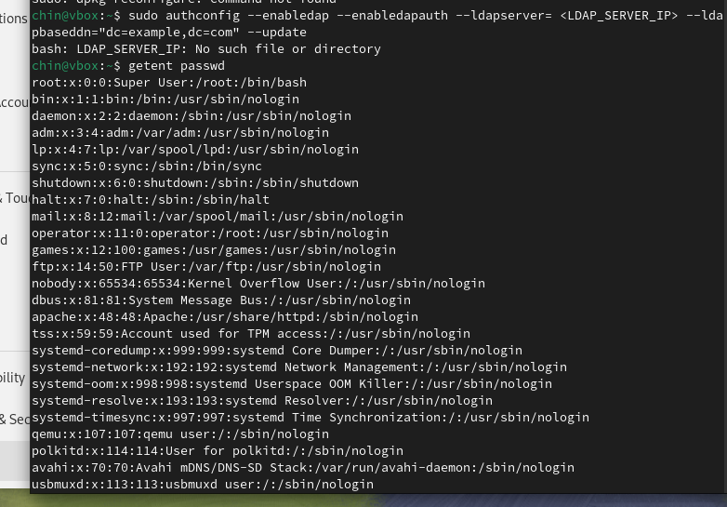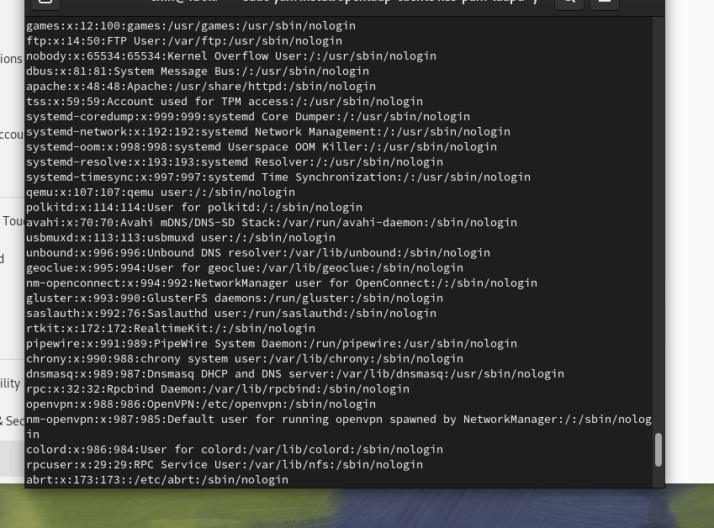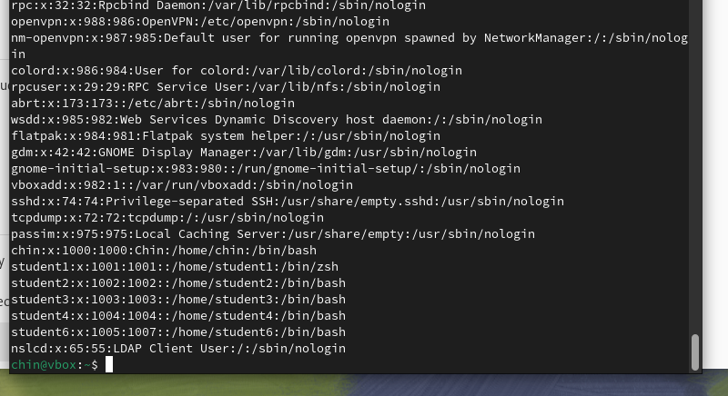

getent group

